**Combined Effects of Electrostatic Force and Scrubbing to Clean Heliostats**

James Milam

**Introduction**

Concentrating solar-thermal power (CSP) systems look to be a promising addition to the future of energy supply. As of January 2014, the total CSP energy generated exceeded 3000 MW with Spain having the highest amount generated at 2300 MW. To achieve relevance in the energy market however, CSP systems will need increase their economic competitiveness and fit the environments in which they would be most efficient. The best environments for CSP are ones which experience insignificant amounts of beam scattering and therefore have a larger direct normal component. In this situation, the majority of the incident radiation is capable of being accurately redirected for power usage. One often overlooked development direction in increasing the economic viability of CSP systems is the maintenance of the reflectance of the heliostat surfaces. Over time dust and soil will settle on the reflective surfaces of the heliostats lowering the reflectance of the surface and degrading the performance of the system overall.

The soiling of the heliostat surface deteriorates the performance of the CSP system in two primary ways; “It reduces the spectral reflectance at every wavelength and induces diffuse reflectance”. By reducing the spectral reflectance at every wavelength, the soil has reduced the overall power that the heliostat is reflecting towards the target surface. Inducing diffuse reflectance does not decrease the amount of power reflected by the surface but will reduce the surface’s capability to aim the reflected light towards its target surface to be collected for power usage. Thus, the presence of dust and particulates on the surface of the heliostat will be a hindrance towards system efficiency and a method of removal will be needed.

Some examples of particles that comprise the dust are fertilizers, dirt, particulates from vehicle exhaust, particulates from construction, etc. These particles are carried to the heliostat surface in one of two primary ways, wind and water. Wind deposition is self-explanatory; particles being carried by the wind land on the surface of the heliostat. Water can bring particles to the surface of the heliostats in the form of rain. Previous studies have shown that heavy rains can work to restore reflectance of the heliostat but light rains carry and leave deposits on the surface and thus lower the reflectance. Once the particles are on the heliostat, they can be held to the surface by different adhesion methods including the force of gravity and electrostatic charge. Also, the particle has the possibility of being cemented to the heliostat surface. If the particle does cement to the surface of the heliostat, more rigorous methods of cleaning will be needed for their removal.

Early methods to combat soiling of the heliostats were restorative measures. These are methods that are used intermittently (once a day, once a week, etc.) to bring the reflectance of the heliostats back to original values. The two most common of these restorative measures are scrubbing and spraying where in scrubbing a cloth is used to wipe the buildup from the surface and in spraying a detergent with water is used to flush the buildup from the surface. These methods are displayed in Figure 1. Spraying is a quicker procedure than scrubbing but it does not get cemented soil off the reflective surface. Also, spraying uses significantly more water than scrubbing which can be problematic in environments lacking in water and such environments tend to be the ones most suitable for CSP systems. Thus, scrubbing would be the more ideal method of cleaning the surfaces of the heliostats and ways to increase the cleaning speed of the scrubbing method should be investigated.

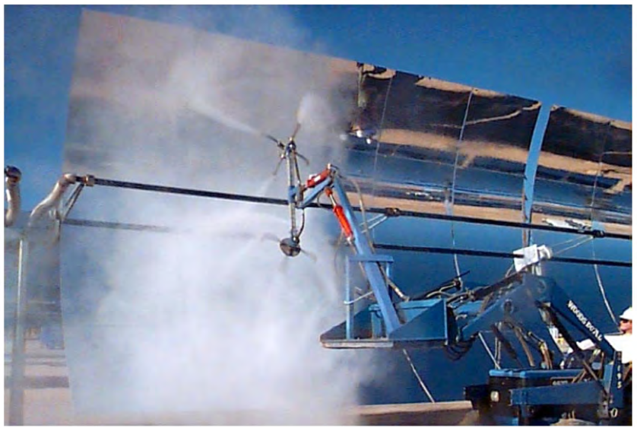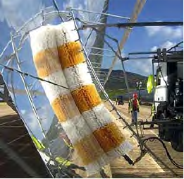

Figure 1: Spray and Scrubbing Heliostat Restoration Methods [1]

A newer method of combating soiling of the reflectance of the surface of the heliostat is by use of an electrodynamic screen. This method falls under the category of preventative measures as it can be constantly at work. In this method, an electric current is run in electrodes along the surface of the heliostats. This creates an electric field around the electrode and the resultant force of charged dust particles in the field will move the dust particles away from the surface. Each individual electrode does not move the dust far and so the electrodes in an electrodynamic screen are arranged such that they pass along the dust until the dust is removed from the screen entirely. An example is to place the electrodes in a spiral pattern, as displayed in Figure 2, and thus the dust would be moved outward from the center of the electrodynamic screen. Since this method of keeping the heliostat surface clean does not require any mechanical motion or operator input, it is attractive as it could be more cost effective.

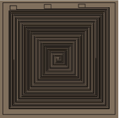

Figure 2: Electrodes in a Spiral Array [2]

The research being proposed in this paper is to use the electrodynamic screen in conjunction with scrubbing as a restorative measure for cleaning the heliostat surfaces. For this method, the electrodynamic screen would only be powered during the scrubbing and thus would act as a restorative measure instead of a preventative measure. The idea is that the electrodynamic screen would create an electrostatic force on the dust and soil that has settled on the heliostat and the component of the force normal to the heliostat surface would make scrubbing the surface faster as it would be pushing the particles off the screen as the cloth comes over the surface. For such a method, it would not be necessary to arrange the electrodes in a pattern that moves the soiling to the edge of the electrodynamic screen. It simply needs to provide an outward force to make wiping the surface easier.

**Literature review**

In the late 70’s there was an increase in research and development of concentrating solar-thermal power systems [3]. These efforts took place in dry, desert regions because these regions are rich in beam radiation (direct normal radiation) which is the primary form of radiation used by CSP systems. Unfortunately, these regions are also heavily prone to dust accumulation. Since slight drops in reflected sunlight could have a significant effect on the performance of the CSP system, dust mitigation efforts were undertaken. One of the main locations for the original research both into CSP systems and dust mitigation took place at Sandia National Laboratories. An example of one of these studies was to test the reflectance drop by varying the mounting angle of heliostats over a period of five days. The results from this study, as can be seen in Figure 3, showed that in general shallower slope angles lost reflectance at higher rates, though all of the heliostat surfaces experienced significant loss of reflectance. The exception would be the heliostat that was turned all the way upside down, but even this one experienced a minor decrease in reflectance.



Figure 3: Reflectance Loss Results from Different Tilt Angles [3]

Other early work in desert locations in California and New Mexico made durability and dust effect comparisons between a silvered laminated glass reflective surface and a silvered glass with an acrylic protective coating [4]. This study varied tracking positions and compared reflectance losses under different weather conditions and found that up to 25% loss of reflectivity could occur if there was no cleaning. The studies also included information on the effects of natural cleaning by rain, snow and frost. This work validates the need to research cleaning techniques as it is obvious that allowing dust to accumulate heliostat surfaces can have non-negligible effects on their reflectivity and hinder overall system performance.

Another study on silvered glass mirrors tested the dust buildup’s effect on the specular reflectance and diffuse reflectance of the heliostat surfaces [5]. It was found that the dust reduced the intensity of the specular beam but the beam profile remained unchanged. Also, the reflectance losses across the surface had the same wavelength dependence. As a result of the study, researchers can safely take reflectance measurements at a single wavelength and not worry that other wave lengths are being affected by the dust build up in a different manner than the measured one.

Work has been done to test the effects of electrode width and inter-electrode spacing [6]. The study found that increasing the inter-electrode spacing caused a drop in maximum electric field norm. In addition, it was found that increasing electrode width will also cause a drop in maximum electric field norm. The rate of maximum electric field norm drop was much greater for increasing inter-electrode spacing than it was for increasing electrode width and thus inter-electrode spacing is of greater concern when designing an electrodynamic screen.

The effect of the thickness of the dielectric layer above the electrodes on the electric field produced has also been studied [6]. It was found that as the dielectric layer increased, the electric field decreased. Also important to note was that the rate of decrease of the electric field in the direction along the surface of the electrodynamic screen was found to be less than the rate of decrease of the electric field in the direction normal to the electrodynamic screen.

Studies have been done on the effectiveness of different methods of producing the electrodynamic screen [2]. One study compares the use of photolithography, screen printing and microplotter inkjet printing. Of these methods screen printing is the cheapest but cannot create transparent electrodes like photolithography can. This means that some optical efficiency will have to be sacrificed in order to lower cost when producing in bulk. This study also reported values for their electrodynamic screen cleaning process. They used a supply voltage of 1 kV and required a power of 10 W/m2 to clean the electrodynamic screen in about two minutes. This amount of power is negligible compared to traditional cleaning methods like scrubbing and was able to restore the power being collected by more than 90% each cleaning operation.

In another study, the effects of electrodynamic screen configuration was tested [3]. This study tests two configurations of electrodynamics screens, one where the electrodes are placed on a glass substrate and have two dielectric layers on top and a second configuration where two dielectric layers are placed atop the metal reflector and the electrodes are placed on top of the second dielectric layer followed by a third dielectric layer placed above the electrodes. The effect of the first configuration was solved numerically and compared with existing experimental results with maximum error percentages around 7%. The second configuration was only solved numerically by using finite element analysis techniques. When the results of the two configurations are compared, it is found that there is no significant difference between the two setups. The two configurations were compared using the component of the electric fields normal to the electrodynamic screen surface.

Electrodynamic surfaces are not the first form of automated cleaning for heliostat arrays. Other forms in the past include autonomous robots with cleaning gear [7]. One type of robot would be hung from the mirror and used pulleys to traverse the vertical length of the surface. The attachment point at the top of the mirror would then translate horizontally when the full vertical length had been cleaned and the process would be repeated. This robot would use a rotating cylindrical brush to clean the panel and a scraper to remove the dirt buildup. Another automatic cleaning robot named ‘HECTOR’ would contain its own battery and water supply and, using sensors, would traverse the surface of a heliostat placed in a horizontal position. HECTOR could perform its cleaning operations day or night but it performed this task very slowly and its entire weight rested on top of the reflective surface. The concern was that this could lead to the robot damaging the surface of the heliostat. Other larger automated robots move autonomously in between rows of heliostats to clean. These systems can be of the spraying or scrubbing variety. The heliostats are rotated to face inwards towards the row and the autonomous vehicle drives equipped with sprayers that can clean two rows of heliostats at a time. Similarly, cylindrical brushes can be attached on robotic arms that traverse the surface of the heliostat. These systems too can contain spraying elements to assist in soiling removal. An example of this type of system 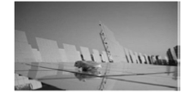would be the PARIS autonomous cleaning system created by Sener [8].

Figure 4: HECTOR Automatic Cleaning Robot [7]

In addition to automated robots, spraying systems have been used. These systems are similar to automatic lawn watering systems in that attached nozzles would protrude above the heliostat surface and spray the mirrors. This system has its own reservoir of detergent and by using a controller can perform timed wash and rinse cycles. The detergents for such systems are chosen for being able to reduce the surface tension, being low cost, being able to be handled and mixed in automated equipment and being safe, non-toxic and biodegradable [3]. These characteristics are necessary for prolonged use for economic and environmental reasons. Instead of using a detergent, a spray system for cleaning heliostats can also use water at high pressures with a sheeting agent. Spray systems have been found to return a heliostat surface’s reflectivity to 98% of its original value for a glass surface and 92-95% of its original value for an acrylic surface. Naturally though a spraying system would require heavy water usage and thus would be less desirable in water scarce environments such as deserts where CSP systems are often located.

Other systems that can be used to clean a heliostat surface through mechanical means include forced air systems and vibrations [3]. In forced air systems, high pressure air is blown across a soiled mirror surface in order to remove accumulated dust. For this method variations in velocity, duration, angle of incidence and gas type have been studied. Also, different types of nozzles have been assessed to see if imparting a rotational motion to the air would create a scrubbing motion that would assist in dust removal. Another aspect of forced air systems that has been tested is the use of a piezoelectric transducer to create ultrasonic pulses in the blown air. These methods have proven to be effective at restoring reflectance to heliostat surfaces but they are not as effective as more traditional washing methods.

An electrostatic force restoration method that doesn’t use a large array of electrodes like previously discussed would be a two-comb type-electrodes setup as shown in Figure 5 [7]. In this setup, there are two electrodes with long portions like teeth on a comb and these “teeth” are meshed together. One of the two electrodes is provided an AC voltage while the other is grounded. This will cause charged particulates to be lifted off the surface and escape the stress zone. A drawback of the two-comb setup is that it requires a very dry surface and thus is more useful for extraterrestrial purposes such as the PV equipment for the Mars rovers as even desert environments will encounter some moisture.

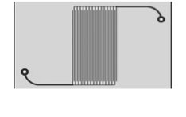

Figure 5: Two-Comb Type-Electrode Setup [7]

In addition to cleaning the heliostat surface, the problem of dust accumulation can be fought using some additional techniques and technologies [3]. One such technique is the invert the heliostat surface overnight or during a dust storm. This way the dust will be less likely to stick to the reflective surface as gravity will act against adhesion rather than for adhesion. Another method of dust prevention is to use turbidity spoilers around the heliostats. These spoilers act to create turbulent air flows over the surface of the heliostats which makes dust removal rather than dust settling more probable. This technology is still new and more testing will need to be done to determine its effectiveness. Lastly, devices can be attached to the heliostat surface that induce vibrations. These devices would be activated during dust storms or general periods of high dust accumulation. The vibrations would make it less likely that dust would be able to settle and more likely that the dust would be rejected back to the air. The vibrating devices could also potentially be used as a restorative measure to remove previously settled dust.

**Relevant Physics**

*Dust composition:*

The dust that falls on the surface of the heliostats can vary widely, even in similar parts of the world [3]. Analyses of dust sand in the United States found a composition of mostly quartz silicates, around 75%, and feldspars, around 20%. A study on the composition of dust near Cairo, Egypt found particulates from the nearby cement industry in addition to the expected quarts and feldspars. Studies in other regions of Egypt did not have the cement industry particulates but had increased amounts of Na and Cl due to being closer to the Mediterranean and the Persian Gulf. This shows that the composition of dust that can accumulate on heliostat surfaces is highly dependent on the specific location of the heliostat.

*Dust accumulation and settling:*

Soil particles can end up on a heliostat surface by falling due to gravity, becoming electrostatically charged and attracting to the surface, or by being carried by wind and water droplets [3]. Dust particles carried by the wind can attach to the surface of the heliostat from sudden decrease in wind speed after which the particle is no longer able to be suspended. Another method for reaching the surface is when several particles coagulate until their weight is too large to be held in suspension. These particle conglomerates can have irregular shapes, morphologies and charge distributions and thus are generally difficult to model. After being deposited on the surface the sediments can experience multiple different types of adhesion to the surface including gravity, electrostatic forces, surface energy and capillary effects. The capillary effects result from the capillary bridge force that is an effect of the absorbed moisture layer. There can also be a chemical bonding force but this is does not generally appear in dry environments. This bonding force occurs when the particle consists of a water-insoluble component and a water-soluble component. After settling on the surface the moisture in the air will cause the water-soluble component to become a salt solution and this solution later dries around the water-insoluble particle and acts as a glue as is depicted in Figure 6. The moisture in the air in this process can be caused by a period of increased humidity or from dew. This reaction can occur in the first hour the dust has been on the mirror surface causing the adhesion to quickly increase.

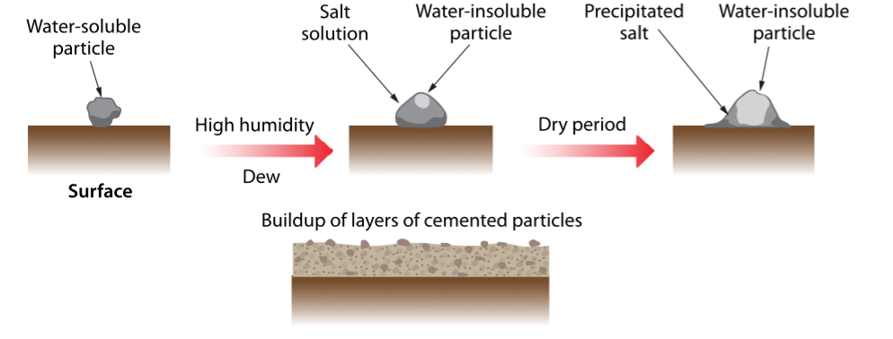

Figure 6: Soil Cementation Process [3]

*Electrodynamic screen basic principles:*

The electrodynamic screen is provided a high, three-phase voltage from an external power source. This voltage creates a traveling wave with strong translational energy which will carry the electrostatically charged particle off of the heliostat surface. The dominant force of the repelling forces is the Coulomb force [7]. This force results from the electrostatic charge on the particles being influenced by the electric field produced by the electrodes of the electrostatic screen. The repelling forces will have to overcome the attraction forces that are holding the particle to the surface and these can include van der Waals forces and capillary forces. New particles that fall on the surface will also become electrostatically charged due to polarization of charge or induction and this will allow the electrodynamic screen to remove these particles as well.

*Dust charging:*

The dust particles on the surface of the heliostat can become charged by electron exchange between the atoms in the dust and the dielectric surface [2]. For example, if the dielectric surface is highly electronegative, the atoms in the dust particles will lose electrons to the surface. This will cause the surface to build a negative electrostatic charge and the dust to develop a positive electrostatic charge. In this scenario, the atoms in the dust particle acted as electron donors and the atoms in the dielectric surface acted as electron acceptors. After this process the dust particle is now charged and ready to be acted upon by the electric field produced by the electrodynamic screen.

As this process continues, the dielectric surface would eventually no longer be able to accept electrons from the dust particles as the surface would already be negatively charged. This is rectified when the electrodynamic screen is powered as the alternating electric field created by the electrodes will alter the surface charge of the dielectric film. In this manner, the film is “reset” and becomes capable of accepting more electrons from the dust particles. Thus, the surface will continue to be able to create charges on the dust particles and the dust particles will continue to be removed by the electrodynamic screen.

**Instrumentation/Experimental Procedure**

The proposed restorative method of combining an electrodynamic screen with scrubbing will be tested with water usage and power level to the electrodynamic screen being varied. For each combination of water usage and power level, the restorative technique will be used on a 1 m x 1 m surface with settled dust and again with cemented dirt. The water and power levels are being varied to test economic viability of the system. In some environments water is scarce and so it will need to be determined if the heliostat surface can be sufficiently cleaned with lower amounts of water. Similar reasoning holds for varying the power to the electrodynamic screen. If the cleaning process is sufficiently fast enough at lower power levels, then energy and money can be saved in the maintenance of the heliostats. The power levels for the electrodynamic screen will be varied from 0% to 100% power in increments of 20% where 100% power is 10 W/m2. The water usage for each power level will vary from one gallon to 5 gallons in increments of a gallon. Each trial will have the restorative method return the reflectance of the surface to 97-98% of the original reflectance and measure the time this took to achieve.

The electrodynamic screen for the experiment will be created by a screen printing process. This is in an effort to save money as this process is described as the least expensive between it, photolithography and micro plotter inkjet printing. Like the mirror surface, the electrodynamic screen will need to be 1x1 m2 in size. The following screen printing process is also described in Mazumder [2]. Borosilicate glass plates will be used as the substrates for the process and will be surface treated using oxygen plasma to aid adhesion of the conducting ink. For this experiment the electrodes will be printed using silver based screen-printing ink. The conducting and dielectric inks will need to be cured for 30 min at 120 C°. The electrodes will be connected to the electrodynamic screen power supply by silver paste conductive epoxy. The transparent dielectric film over the electrodes will be made from polyurethane. The electrodes in the screen will be made of tin doped indium oxide (ITO) and will thin rectangles in shape with a width of 50 μm and a thickness of 10 μm.

Scrubbing will be done with a setup imitating a single arm of the Paris autonomous cleaning robot produced by Sener [8]. This is a robotic arm with rotary brushes that will move along the surface of the heliostat. The force of the cloth on the surface of the heliostat is entirely from the rotating motion of the cloth. This could lead to difficulties removing more cemented soil but should reduce the risk of scratching the surface as most of the force will be tangential to the surface rather than normal to it. To further decrease the risk of damage to the heliostat surface, the brush will use microfiber cloths. In addition to the cloths, the arm includes sprayers for the water/detergent to wet the surface and make removing the soiling quicker and more effective. For the experiment the spray nozzles will be located below the brush arm. This arrangement assures that as the arm descends across the heliostat surface the surface will be wetted prior to coming in contact with the brushes. This will help lubricate the point of contact thus reducing potential to scratch the heliostat surface in addition to dissolving the water-soluble portion of the soil and freeing up the water-insoluble portion, thus making their removal easier.

To measure the reflectance of the heliostat surface a D&S Reflectometer 15 will be used. This device is “used as the industry standard” and “is the reference in most publications”. To determine the reflectance of the surface, measurements will be taken at 9 points in an evenly spaced 3x3 grid on the heliostat [1]. These measurements will be averaged together and used as an overall reflectivity of the device. The reasoning for the multiple measurements is that the D&S Reflectometer is only measuring at a point location and a thus a single measurement would be unlikely to provide an accurate representation of the reflectance of the screen. The number of points measured may be increased if it is determined that 9 points will not be accurate at the time of the experiment. A potential shortcoming of this method is that the device only measures a single wavelength rather than testing across a spectrum. Devices and Services Company also makes multiple wavelength specular reflectometers that can be obtained instead if it is later decided that this functionality is desired, however, as mentioned earlier the other wavelengths should be affected by the dust build up in a similar manner to the wavelength being measured.

Two different soiling processes will be used in the experiment, settled dust and cemented sediment. The differentiation is being used because one of scrubbing’s recorded advantages over spraying is its ability to remove cemented sediment [1]. Thus, it is desired to see whether or not the addition of an electrodynamic screen will help with this soiling type. Cemented sediment may not be common in areas that do not experience periods of increased moisture and so this is also being tested so that the cleaning method’s effectiveness in these environments can also be established.

To simulate dust buildup on the surface of the reflector a sieve will be held over the screen and shaken for 4 seconds and the reflectance of the screen will be measured. The goal is to reduce the reflectivity of the heliostat by roughly 70%. The sieve will be shaken again in 1 second intervals until the reduction in reflectivity has reached the desired amount. If at the time of experiment it becomes apparent that these times are unreasonable to achieve 70% reduction in reflectivity or a 70% reduction in reflectivity is deemed too large or small for testing, these values are subject to change.

For accelerated cementation of sediment buildup, the sieve will be reused this time with dirt particles. Prior to using the sieve, the heliostat surface will be sprayed with a mister to simulate moisture from dew. The sieve will be shaken in the same manner as for the settled dust where the shaking duration is decreased as it approaches the desired 70% decrease in reflectivity of the heliostat surface. After the reflectance drop is reached, 1 hour will be given for the surface to dry. This time may need to be altered at the time of the experiment if it is found that after an hour the surface has not yet satisfactorily dried. If the drying process is taking too long it can be increased by heating the surface. The drying process should not be accelerated by means of air drying for concerns that it would blow away some of the sediment and alter the experiment results.

**Expected results**

The fastest cleaning rate should be when the electrodynamic screen is receiving the most energy and the full amount of water is being used. This should be expected as it is using the maximum resources available to clean the surface. As each resource is reduced in quantity, either volume or power, an increase in the amount of time to clean the heliostat surface should be expected. At low power levels the rate of increase in cleaning time may drop off. If this happens it could be speculated that the power levels were too low for the Coulomb force on the dust particles to have a significant effect. Similarly, there may be stagnation in the rate of cleaning time decrease as power levels near peak power. This would occur if the Coulomb force reached levels sufficient enough to counteract some specific adhesion forces but is not great enough to counteract the remaining adhesion forces. The variation in water usage may end up having no effect in cleaning times as the different volumes chosen may be too large. This would mean that additional water wouldn’t actually be used in the cleaning process, but rather wasted.

Overall the resources put in to cleaning the heliostat surface should be optimized for effectiveness of cleaning and time needed to clean. For instance, although slower, a combination that uses less water with insignificant increase in heliostat cleaning time would be desired especially in regions where water is scarce. Also, it may turn out that the electrodynamic screen has no effect on the cleaning speed of the heliostat. In this case the electrodynamic screen would be completely unnecessary and would reduce the economic competitiveness of the CSP system. Lastly it may be found that the cleaning time does not vary greatly across any of the different resource combinations. This would mean that the bottleneck for the scrubbing method of cleaning the heliostats is not actually in removing the soiling from the heliostat surface but rather the mechanical motion of moving the brushes across the heliostat and moving between heliostats. If this is the case then the electrodynamic screen, though it may speed up dust removal rates, would not greatly decrease overall cleaning speeds.

**References**

[1] Wolfertstetter, Fabian, “Reflector Soiling and Cleaning Methods”, SFERA Summer School, Hornberg, May 2013

[2] M. Mazumder, M. Horenstein, J. Stark, D. Erickson, A. Sayyah, S. Jung, F. Hao, “Development of Self-Cleaning Solar Collectors for Minimizing Energy Yield Loss Caused by Dust Deposition”, Proceedings from ASME 2013 7th International Conference on Energy Sustainability, July 2013

[3] T. Sarver, A. Al-Qaraghuli, L. Kazmerski, “A Comprehensive Review of the Impact of Dust on the Use of Solar Energy: History, Investigations, Results, Literature, and Mitigation Approaches”, Renewable and Sustainable Energy Reviews, April 2013

[4] Blackmon JB, Curcija M. “Heliostat reflectivity variations due to dust buildup under desert conditions”, Seminar on Testing Solar Energy Materials and Systems, 1978:169-83

[5] Pettit R.B., Freese J.M., Arvizu, “Specular Reflectance Loss of Solar Mirrors Due to Dust Accumulation”, Sandia National Laboratory. In: Proceedings of the institute of environment sciences seminar on testing solar energy materials and systems; May 1978. p. 164-8

[6] A. Sayyah, M.N. Horenstein, M. K. Mazumder, G. Ahmadi, “Electrostatic Force Distribution on an Electrodynamic Screen”, Journal of Electrostatics, March 2016

[7] A. Mondal, K. Bansal, “A Brief History and Future Aspects in Automatic Cleaning Systems for Solar Photovoltaic Panels”, Advanced Robotics, April 2015

[8] Sener, “PARIS-Autonomous cleaning system for Parabolic Troughs”

[9] A. Sayyah, M.N. Horenstein, M. Mazumder, “A Comprehensive Analysis of the Electric Field Distribution in an Electrodynamic Screen”, Journal of Electrostatics, May 2015